**HTML PARAGRAPHS**

* A paragraph always starts on a new line, and is usually a block of text.
* Is is denoted as <p>…. </p>
* EXAMPLE :

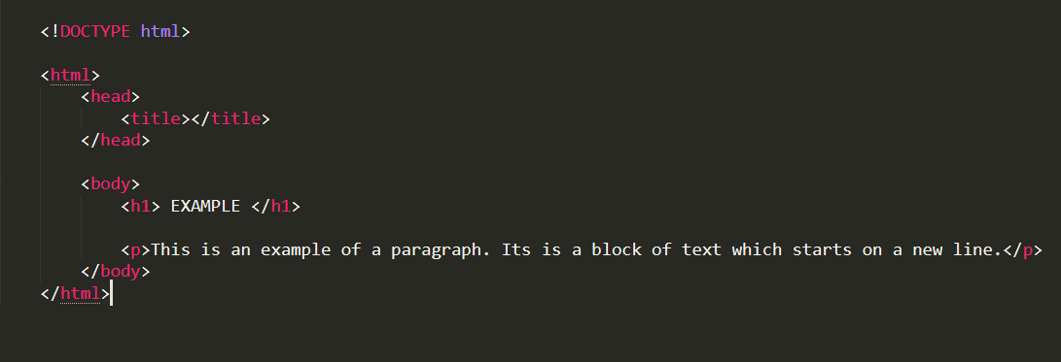

* OUTPUT :

